Southwestern Association of
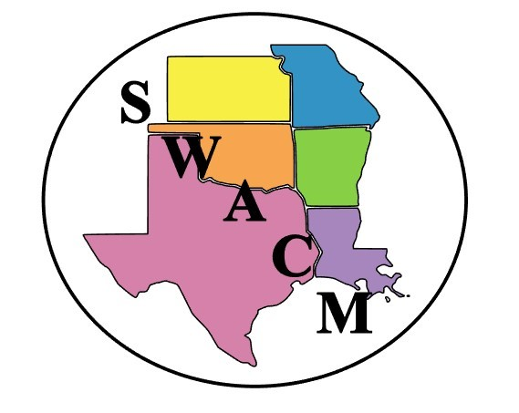
Clinical Microbiology

TRAVEL GRANT APPLICATION FOR SWACM ANNUAL MEETING

Submit application via email to Mary Ann Henthorne (maryann.henthorne@gmail.com) by July 8th, 2024.
Answers to all questions and supervisor signature are required for consideration.

Grants of $500 will be awarded during the annual meeting. Applicants will be notified of the status of the award by July 12th, 2024.

Award winners are required to be or become active SWACM members, must register for the full 2-day general session (attendance at workshops is encouraged but not required), and must register for 2-nights’ hotel stay under the SWACM room block.

Name
Institution
Role / Title
Phone
Email

Are reimbursement funds available from your institution for travel to educational events?
☐Yes
☐No

Have you attended a SWACM annual meeting in the past?
☐Yes
☐No

Please provide a short statement describing how you hope to benefit from attending this year’s event:

Applicant Signature_____________________ ______________ Date_______________

Supervisor Signature__________________________________ Date_______________

