Southwestern Association of
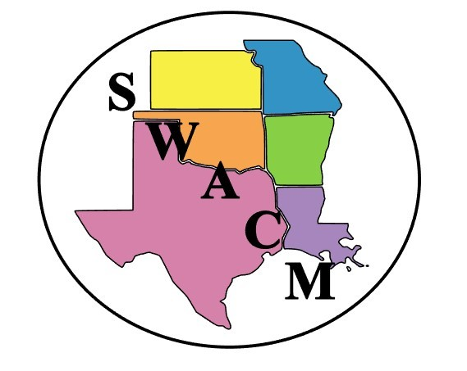
Clinical Microbiology

CASE REPORT/ABSTRACT SUBMISSION GUIDELINES

Case Report:
Case reports should be no more than 2,200 characters, including title, authors, and affiliations. The case report submission should clearly highlight the novelty or interesting characteristics of the case. Submission of case reports from bench-level laboratory scientists is encouraged.

Abstract:
Abstract should not exceed 2,200 characters, including title, authors, and affiliations.
The abstract should be as informative as possible, including:
a) a sentence stating the study’s specific objectives;
b) a brief statement of the methods;
c) a summary of the results obtained; and
d) the conclusions based on the results.

Posters should be no larger than 72” (L) x 48” (H). We recommend a standard poster size of 48” (L) x 36” (H), with a horizontal orientation.

Cash prizes will be awarded for outstanding poster and best case study.

Posters must be in place for viewing by the beginning of the general symposia on Thursday, August 22nd. Authors should be at their posters for viewing and judging on August 22nd from 1-2:30pm. Poster awards will be presented during the business meeting on Friday, August 23rd.

Submit the below form via email to Mary Ann Henthorne (maryann.henthorne@gmail.com) by August 2, 2024.

CASE REPORT/ABSTRACT SUBMISSION FORM

Presenting Author: Click or tap here to enter text.
Institution: Click or tap here to enter text.
Email: Click or tap here to enter text.

Title:

Authors and Affiliations:

Case Report/Abstract:

